Newton Music Teachers Associaton Presentation, September 26, 2017 by Dr. Brett Janssen
TAKADIMI
- A preliminary comparative study of rhythm systems employed within the first-year college aural skills class
  - Rhythmic Literacy and Rhythm Systems
  - Purpose: To discover if differences exist in rhythm pattern achievement of three rhythm systems (Takadimi, 1 e & a, and 1 ta te ta) in the first level college aural skills classroom.
  - Research Questions
    - 1. Is there a difference in achievement among rhythmic skills based on the instruction and usage of a specific rhythm system?

    - 2. Is there a difference in student achievement between students with low and high aptitude as measured by (AMMA) following instruction in a particular rhythm system?
  - Counting vs. beat-oriented rhythm systems
  - Learning Theories
    - Gagné
    - Pestalozzi
    - Gordon
    - Ester’s Sound Connection curriculum
    - Memory: Chunking
  - The study: Treatment, results, discussion, conclusion

- Application to piano instruction
Purpose/why this relates to piano.
  - Introducing new rhythms within piano repertoire
  - Introducing polyrhythms within piano repertoire
  - Working with Music Progressions curriculum
    - Writing rhythmic beats within the measure
    - Rhythmic dictation
    - (1) Neutral Echoing, (2) Syllable Echoing, (3) Echo-Translation, (4) Connecting Sound to Symbol, (5) Application and Practice, (6) Notating, (7) Melodic Reading (Ester, 2010, pg 67)

Figure 1: Rhythm System Syllables
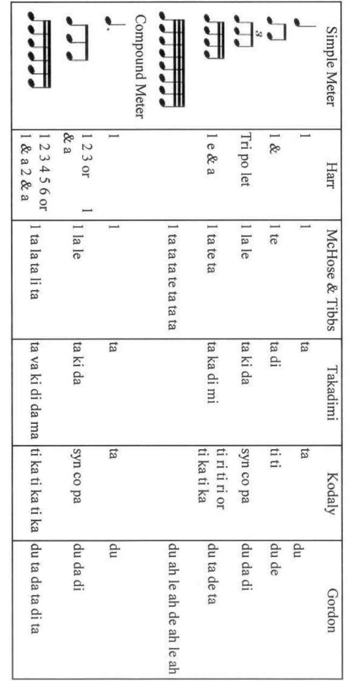

Figure 2: Rhythm Patterns Presented In Each Rhythm Lesson
Lesson Content
Lesson 1 Lesson 5 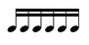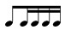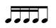
Lesson 2 Lesson 6
Lesson 3 Lesson 7
Lesson 4 Lesson 8 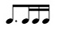

Figure 3: Distribution of Student Population: Rhythm Systems
 | 1 e & a | Du ta de ta | TTTT | 1 ta te ta | Ti ri ti ri | Takadimi | Car, Airplane
Taught to read rhythm | 23 | 1 | 2 | 1 | 4 | 1 | 2
Currently read rhythm | 26 | 0 | 1 | 1 | 2 | 1 | 0
Figure 4: Rhythm System Gains by Metrical Pattern and Aptitude Level
 | 1 ta te ta | 1 e & a | Takadimi
Simple | 20% | 71% | 244%
Compound | 17% | 56% | 780%
Combined | 19% | 65% | 436%
Low Aptitude | - | 900% | 225%
Medium Aptitude | 9% | 71% | 1700%
High Aptitude | 177% | 225% | -

Figure 5: Vowel Placement in Takadimi
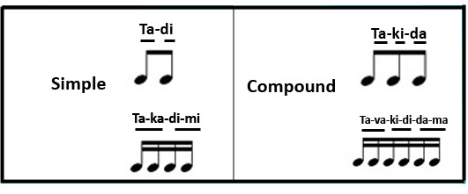
Figure 6: Takadimi Polyrhythms
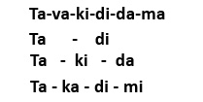
Figure 7: Gallop, Op. 39, No. 18, by Kabalevsky
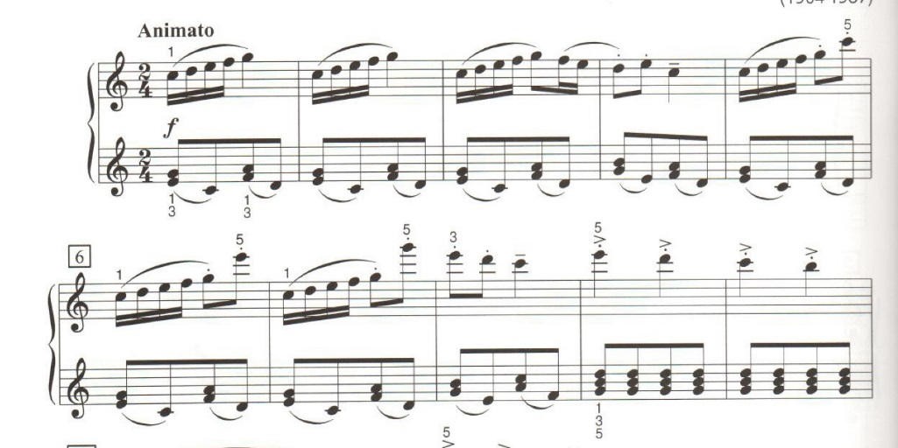
Figure 8: Sonatina, Op. 36, No. 6, II. Rondo, by Clementi
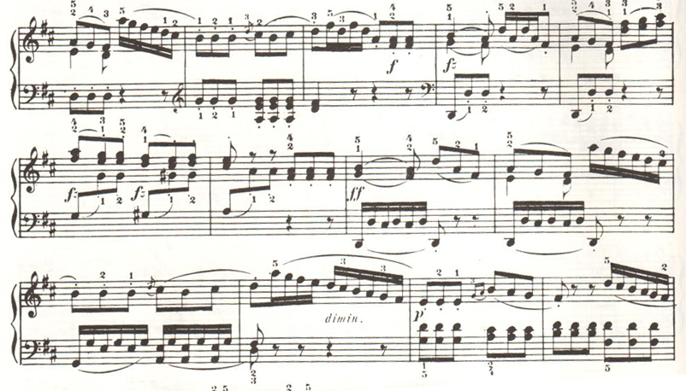
Figure 9: Nocturne in C# Minor, Posthumous, by Chopin

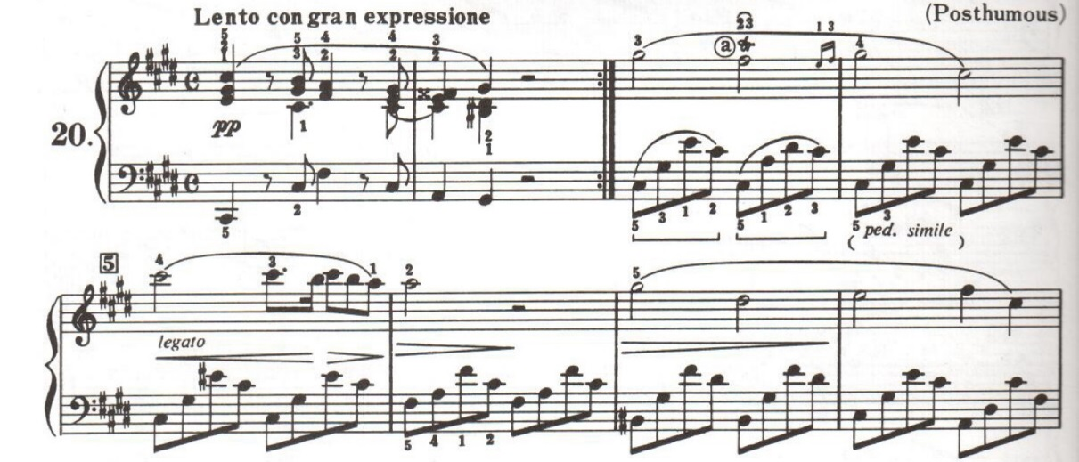
Figure 10: Fantasie-Impromptu, Op. 66, by Chopin

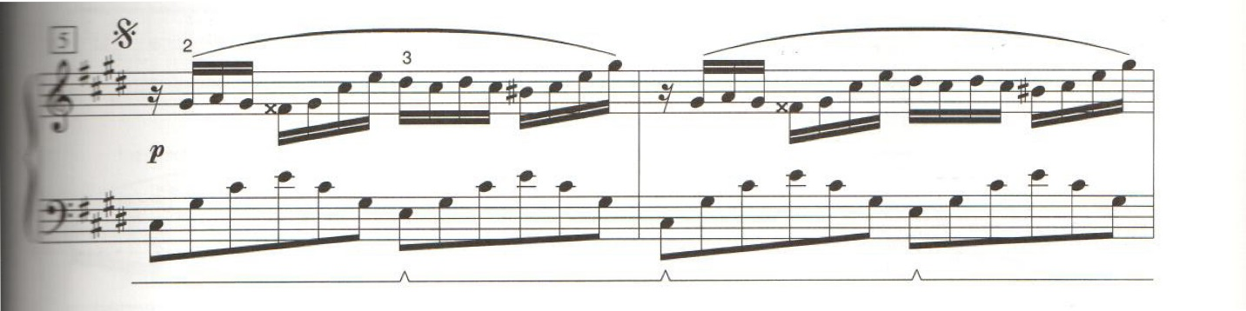

References
Palmer, W. A. ed. (1992). Chopin: Nocturnes for the piano, 2nd ed. Alfred.

Clementi, M. (1893). Sonatinas for the piano, op. 36, 37, 38, ed. Koehler. Schirmer.

Colley, B. (1987). A comparison of syllabic methods for improving rhythm literacy. Journal of Research in Music Education, 35(4), 221-235.

Ester, D.P. (2010). Sound connections.

Ester, D.P., Scheib, J.W., & Inks, K.J. (2006). Takadimi: A rhythm system for all ages. Music Educators Journal, 93(2), 60-65.

Gagné, R.M. (1985). The conditions of learning. 4th edition. Orlando, FL: Holt, Rinehart, and Winston.

Gordon, E.E. (1989). Advanced measures of music audiation test. Chicago: GIA.

Gordon, E.E. (2012 ed.). Learning sequences in music: Skill, content, and patterns. Chicago: GIA.

Hill, G.L. (2008). Teaching rhythm to beginning piano students: An analysis of various counting systems and the integration of Kodály and Orff rhythm strategies (Doctoral Dissertation). Retrieved from Dissertations and Theses – Full Text. (3361149)

Hoffman, R., Pelto, W., & White, J.W. (1996). Takadimi: A beat-oriented system of rhythm pedagogy. Journal of Music Theory Pedagogy, 10, 7-30.

Miller, R.E. (1988). Contributions of selected music skills to music sight-reading achievement and rehearsed reading achievement. Dissertation Abstracts International, 50, (02). (UMI No. 8908779)

Kansas Music Teachers Association (2006). Music progressions: A comprehensive musicianship program curriculum guide, 5th ed.

Ormrod, J.E. (2004). Human learning. 4th edition. Upper Saddle River, NJ: Pearson. 154-321.

Ottman, R. & Rogers, N. (2010). Music for sight singing. 8th edition. Upper Saddle River, NJ: Pearson.

Palkki, J. (2010). Rhythm syllable pedagogy: A historical journey to takadimi via the Kodály method. Journal of Music Theory Pedagogy, 24, 101-130.

Paney, A.S., and Buonviri, N.O. (2014). Teaching melodic dictation in advanced placement music theory. Journal of Research in Music Education, 61(4), 396-414.

Potter, G. (1990). Identifying successful dictation strategies. Journal of Music Theory Pedagogy, 4(1), 63-70.

Rogers, M.R. (2004). Teaching approaches in music theory: An overview of pedagogical philosophies. 2nd edition. Carbondale, IL: Southern Illinois University Press. 143-145.

Snell, K., ed. (1997). Piano repertoire: Romantic and 20th century, level 2. San Diego, CA: Kjos.

Snell, K., ed. (1997). Piano repertoire: Romantic and 20th century, level 10. San Diego, CA: Kjos.

Varley, P.C. (2005). An analysis of rhythm systems in the united states: Their development and frequency of use by teachers, students, and authors; and relation to perceived learning preferences (Doctoral Dissertation). Retrieved from Dissertations and Theses – Full Text. (3189102)

Walters, D.L., & Taggart, C.C., ed. (1989). Readings in music learning theory. Chicago, Il: GIA.

